**LBTR44F Series**

**4-Port 10/100Base-TX +4-Port 100Base-FX Industrial Ethernet Switch**

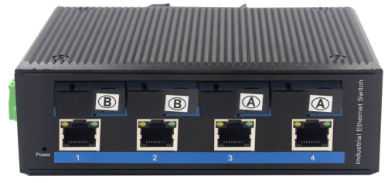 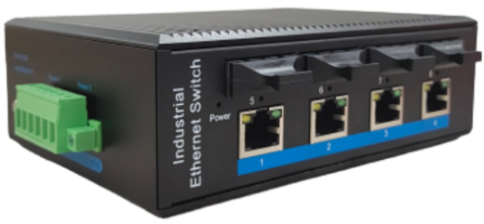

**Interface**

* 4-port 10/100Base-Tx RJ45 with auto negotiation and auto-MDI/ MDI-X function
* 4-port 100Base-Fx interface SC/FC/ST/SFP
* Multi-Mode up to 2km
* Single-Mode up to 20km/40km/60km/80km

**Industrial conformance**

* 12V to 52V DC, redundant power input
* -40℃ to 80℃ operating temperature
* IP40 aluminum housing
* Supports 6KV DC Ethernet ESD protection
* Supports 6KV DC EFT protection for power line
* Free Fall, Shock and Vibration Stability
* DIN-rail hardware design

Yuhang 10/100Base-TX to 100Base-FX Industrial Media Converter, extends communication distance with stable performance via fiber optic wire, in which the extended distance could be up to 2km with the LBTR44F-SC2, up to 20km with the LBTR44F-SC20 .

The LBTR44F series is specifically equipped with durable components and strong housing case to operate reliably in electrically harsh and climatically demanding environments. The industrial level media converter provides a high level of immunity to electromagnetic interference and heavy electrical surges which are usually found on plant floors or traffic control cabinets on sidewalk. Being able to operate under the temperature range from -40℃ to 80℃ allows the LBTR44F series to be placed in almost any difficult environment.

Yuhang LBTR44F series 10/100Base-TX to 100Base-FX Industrial Media Converter series efficiently converts data between 10/100Base-TX and 100Base-FX network. The LBTR44F series provides the flexibility to all kinds of 10/100Mbps Ethernet Media on RJ45 port and performs highly stable fiber performance.

The LBTR44F series is packaged in a compact IP40 case ,with DIN rail installation. It provides an integrated power supply with a wide range of voltages for worldwide operation. It also offers dual-redundant, reversible polarity 12V DC to 52V DC power supply inputs for high availability applications requiring dual or backup power inputs.

# **Specifications:**

**ROBOT**

**ROBOT**

|  |  |
| --- | --- |
| Model No. | **LBTR44F-SC2 / LBTR44F-SC20 / LBTR44F-SFP** |
| 10/100Base-TX Port | 4 port RJ-45 auto-MDI / MDI-X |
| 100Base-FX Port | LBTR44F-SC2: 4 SC interface  LBTR44F-SC20: 4 SC Interface  LBTR44F-SFP: 4 SFP Slot |
| Fiber Port Type | LBTR44F-SC2: SC / multi-mode ,up to distance 2km ;  LBTR44F-SC20: SC / single-mode ,up to distance 20km ;  LBTR44F-SFP: Vary on module |
| Optical Frequency | LBTR44F-SC2: 1310nm  LBTR44F-SC20: 1310nm  D44F-SFP: Vary on module |
| Performance Specification | Bandwidth: 1.6Gbps Packet Buffer Memory:1Mbit Packet Forwarding Rate:1.2Mpps MAC Address Table: 2K |
| Installation | DIN rail |
| Maximum Frame Size | 9000bytes packet size |
| Flow Control | Back pressure for half duplex, IEEE 802.3x pause frame for full duplex |
| Enclosure | IP40 aluminum housing |
| LED Indicator | Power: Red  Fiber: Link 2(Green)  Ethernet: Yellow |
| Power Input | 12 to 52V DC redundant power |
| Power Consumption | < 8 watts |
| Surge protection | ±4KV |
| Network Protocols | IEEE802.3 10BASE-T;  IEEE802.3i 10Base-T;  IEEE802.3u;100Base-TX/FX; |
| Network cables | 10BASE-T: Cat3,4,5 UTP(≤100 meter)  100BASE-TX: Cat5 or later UTP(≤100meter)  1000BASE-TX: Cat6 or later UTP(≤100 meter) |
| Industry Standard | FCC CFR47 Part 15,EN55022/CISPR22, Class A  IEC61000-4-2 (ESD): ±8kV (contact), ±12kV (air)  IEC61000-4-3 (RS): 10V/m (80~1000MHz)  IEC61000-4-4 (EFT): Power Port: ±4kV; Data Port: ±2kV  IEC61000-4-5 (Surge): Power Port: ±2kV/DM, ±4kV/CM; Data Port: ±2kV  IEC61000-4-6 (CS): 3V (10kHz-150kHz); 10V (150kHz-80MHz)  IEC61000-4-16 (Common mode conduction): 30V (cont.), 300V (1s) |
| Certification | CE FCC Rohs compliance |
| MTBF | >300,000hours |
| Dimensions (W x D x H) | 143.7 x 103.8 x 47.7 mm |
| Weight | Product Weight: 0.7KG  Packing Weight: 0.8KG |
| Working Environment | Working temperature: -40～80℃ ;  Storage temperature: -40～80℃  Relative Humidity: 5%~95 %( no condensation) |
| Warranty | 1-year replacement with new item; 3-years for main parts. |

**Dimensions**

