**LBTR24F**

**24-port 10/100BASE-TX Industrial Ethernet Switch**

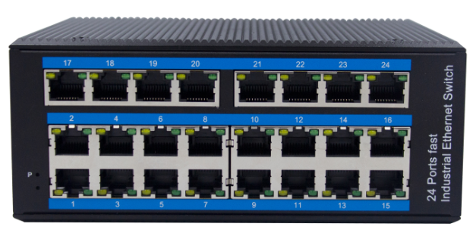

LBTR24F an hardened 24-port Industrial Ethernet Switch, provides non-blocking wire-speed performance in harsh industrial environment. It also provides 24-port 10/100BASE-TX RJ45 copper interfaces delivered in an IP40 rugged, strong case with redundant power system. Its slim case is suitable for such applications as surveillance system deployments, control management and wireless service in climatically demanding environments with wide temperature range from -40℃ to 80℃.

**Interface**

* 24-port 10/100Base-Tx RJ-45 with auto negotiation and auto-MDI/MDI-X function

**Industrial conformance**

* 12V to 52V DC, redundant power input
* -40℃ to 80℃ operating temperature
* IP40 aluminum housing
* Supports Air discharge: ±12kV
* Contact discharge: ±8kV
* Free Fall, Shock and Vibration Stability
* DIN-rail hardware design

The LBTR24F is packaged in a compact IP40 case that allows DIN rail to have efficient usage of cabinet space. It provides power supply with a wide range of voltages for worldwide operation. It also offers dual-redundant, reversible polarity 12V DC to 52V DC power supply inputs for high availability applications requiring dual or backup power inputs.

**Specifications:**

|  |  |
| --- | --- |
| Model No. | **LBTR24F** |
| 10/100/1000BASE-TX Port | 24 port RJ-45 auto-MDI / MDI-X |
| Performance Specification | Bandwidth: 4.8Gbps  Packet Buffer Memory:4Mbit Packet Forwarding Rate: 3.6Mpps  MAC Address Table: 8K |
| Installation | DIN rail |
| Maximum Frame Size | 2000bytes packet size |
| Flow Control | Back pressure for half duplex, IEEE 802.3x pause frame for full duplex |
| Enclosure | IP40 aluminum housing |
| LED Indicator | Power: Red  Ethernet: Yellow |
| Power Input | 12 to 52V DC redundant power |
| Power Consumption | <10 watts |
| Surge protection | ±4KV |
| Network Protocols | IEEE802.3 10BASE-T  IEEE802.3i 10Base-T  IEEE802.3u;100Base-TX  IEEE802.3x |
| Network cables | 10BASE-T: Cat3,4,5 UTP(≤100 meter)  100BASE-TX: Cat5 or later UTP(≤100meter) |
| Industry Standard | EMI ：FCC Part 15 Subpart B Class A，EN 55022 Class A  EMS :  IEC(EN)61000-4-2(ESD) : ±8Kv contact discharge,±12kV air discharge  IEC(EN)61000-4-3(RS) : 10V/m(80～1000MHz)  IEC 61000-4-4 (EFT), Power cord ±4kV  data cable:±2kV  IEC 61000-4-5 (Surge), Ethernet port ±4kV CM//±2kV DM  IEC(EN)61000-4-6(RF conduction) : 3V(10kHz～150kHz),10V(150kHz～80MHz)  IEC(EN)61000-4-24(common conduction) : 30V cont. 300V,1s  IEC(EN )61000-4-8  Shock: IEC 60068-2-27  Free fall: IEC 60068-2-32  Vibration: IEC 60068-2-6 |
| MTBF | 300,000hours |
| Certification | CE FCC Rohs compliance |
| Dimensions (W x D x H) | 166×137×68.5mm |
| Weight | Product Weight: 1.4KGS  Packing Weight: 1.5KGS |
| Working Environment | Working temperature: -40～80℃ ;  Storage temperature: -40～80℃  Relative Humidity: 5%~95 %( no condensation) |
| Warranty | 1-year replacement with new item; 3-years for main parts. |

**Dimensions**

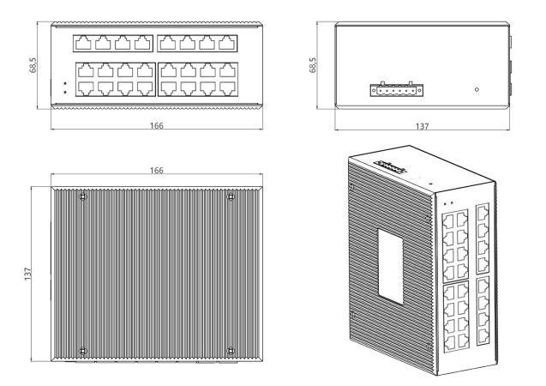

**Ordering Information**

|  |  |
| --- | --- |
| **LBTR24F** | **24-port 10/100BASE-TX Industrial Ethernet Switch** |