**LBTR14F-SFP Series**

**4-Port 10/100Base-TX to 100Base-FX Industrial Ethernet Switch**

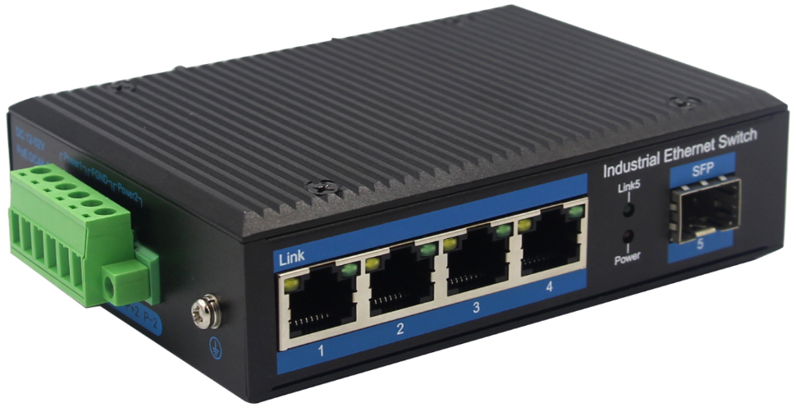

**Interface**

* 4-port 10/100Base-Tx RJ45 with auto negotiation and auto-MDI/ MDI-X function
* 1-port 100Base-Fx interface SC/FC/ST/SFP
* Multi-Mode up to 2km
* Single-Mode up to 20km/40km/60km/80km

**Industrial conformance**

* 12V to 52V DC, redundant power input
* -40℃ to 80℃ operating temperature
* IP40 aluminum housing
* Supports 6KV DC Ethernet ESD protection
* Supports 6KV DC EFT protection for power line
* Free Fall, Shock and Vibration Stability
* DIN-rail and wall-mountable hardware design

**Distance extending Slim Type with more Practicability and Convenience**

10/100Base-TX to 100Base-FX Industrial Media Converter, extends communication distance with stable performance via fiber optic wire。

The LBTR14F-SFP series is specifically equipped with durable components and strong housing case to operate reliably in electrically harsh and climatically demanding environments. The industrial level media converter provides a high level of immunity to electromagnetic interference and heavy electrical surges which are usually found on plant floors or traffic control cabinets on sidewalk. Being able to operate under the temperature range from -40℃ to 80℃ allows the LBTR14F-SFP series to be placed in almost any difficult environment.

LBTR14F-SFP series 10/100Base-TX to 100Base-FX Industrial Media Converter series efficiently converts data between 10/100Base-TX and 100Base-FX network. LBTR14F-SFP series provides the flexibility to all kinds of 10/100Mbps Ethernet Media on RJ45 port and performs highly stable fiber performance.

The LBTR14F-SFP series is packaged in a compact IP40 case that allows either DIN rail or panel mounting to have efficient usage of cabinet space. It provides an integrated power supply with a wide range of voltages for worldwide operation. It also offers dual-redundant, reversible polarity 12V DC to 52V DC power supply inputs for high availability applications requiring dual or backup power inputs.

# **Specifications:**

**ROBOT**

**ROBOT**

|  |  |
| --- | --- |
| Model No. | **LBTR14F-SFP** |
| 10/100Base-TX Port | 4 port RJ-45 auto-MDI / MDI-X |
| 100Base-FX Port ZXR14F-SFP | LBTR14F-SFP: 1 SFP Slot |
| Fiber Port Type | LBTR14F-SFP: Vary on module |
| Optical Frequency | LBTR14F-SFP: Vary on module |
| Performance Specification | Bandwidth: 1.6Gbps Packet Buffer Memory:1Mbit Packet Forwarding Rate:1.2Mpps MAC Address Table: 2K |
| Installation | DIN rail |
| Maximum Frame Size | 9000bytes packet size |
| Flow Control | Back pressure for half duplex, IEEE 802.3x pause frame for full duplex |
| Enclosure | IP40 aluminum housing |
| LED Indicator | Power: Red  Fiber: Link 2(Green)  Ethernet: Yellow |
| Power Input | 12 to 52V DC redundant power |
| Power Consumption | < 3 watts |
| Surge protection | ±4KV |
| Network Protocols | IEEE802.3 10BASE-T;  IEEE802.3i 10Base-T;  IEEE802.3u;100Base-TX/FX; |
| Network cables | 10BASE-T: Cat3,4,5 UTP(≤100 meter)  100BASE-TX: Cat5 or later UTP(≤100meter)  1000BASE-TX: Cat6 or later UTP(≤100 meter) |
| Industry Standard | FCC CFR47 Part 15,EN55022/CISPR22, Class A  IEC61000-4-2 (ESD): ±8kV (contact), ±12kV (air)  IEC61000-4-3 (RS): 10V/m (80~1000MHz)  IEC61000-4-4 (EFT): Power Port: ±4kV; Data Port: ±2kV  IEC61000-4-5 (Surge): Power Port: ±2kV/DM, ±4kV/CM; Data Port: ±2kV  IEC61000-4-6 (CS): 3V (10kHz-150kHz); 10V (150kHz-80MHz)  IEC61000-4-16 (Common mode conduction): 30V (cont.), 300V (1s) |
| Certification | CE FCC Rohs compliance |
| MTBF | >300,000hours |
| Dimensions (W x D x H) | 118 x 86 x 33mm |
| Weight | Product Weight: 0.36KG  Packing Weight: 0.46KG |
| Working Environment | Working temperature: -40～80℃ ;  Storage temperature: -40～80℃  Relative Humidity: 5%~95 %( no condensation) |
| Warranty | 1-year replacement with new item; 3-years for main parts. |

**Dimensions**

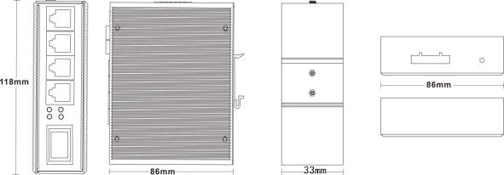

**Ordering Information**

|  |  |
| --- | --- |
| **LBTR14F-SFP** | 4-Port 10/100Base-TX to 100Base-FX, (SFP Slot) |