

**Mbedded 4G router module**

**LTB-T300-M400-C1**

Product specification

# Product overview

**Product overview**

The multi-functional 4G industrial router module is a module supporting 3-port Ethernet, WIFI LAN (802.11 B/G/n) communication, serial DTU, and WAN 4G wireless communication functions, realizing seamless connection between wireless LAN and wireless WAN, and providing users with high-speed, safe, and reliable mobile broadband services. The camera can be fixed to transmit images through the 4G network to provide a stable and reliable network channel for various devices that need to be connected to the Internet. The Ethernet port, TTL serial port and WIFI are used to provide a variety of easy-to-use network access methods for customers' applications, which simplifies the network development needs to the greatest extent.

Support WEB configuration mode, convenient and simple management.

**Application field**

Electricity Petroleum Coal mine Finance

Communication Public security Heat Industrial Control



Weather Water Conservancy Traffic Municipal

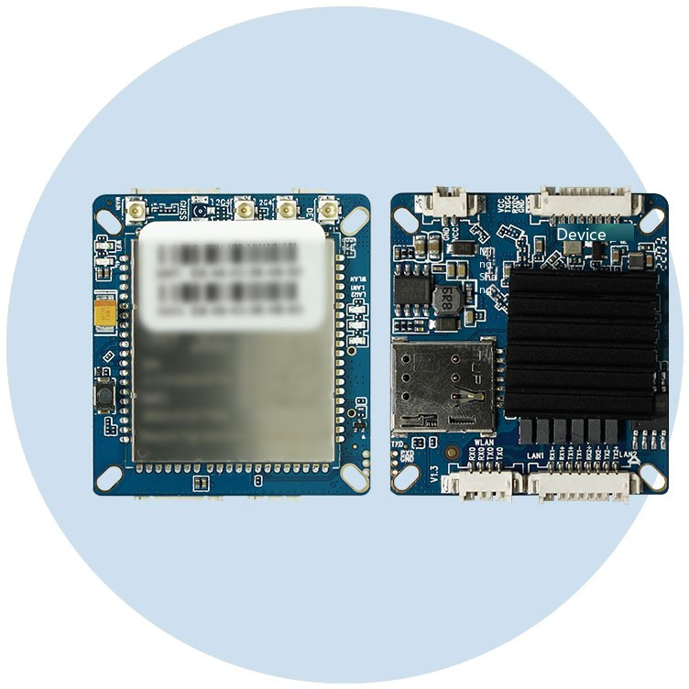

**Product features**

1, ultra-small size, length and width of only 38.0 * 43.5 * 7.5mm

2. 4G wireless communication module of MDM9X07 platform and ASR platform can be freely carried.

(MDM9X07 platform: CLM920 _ NC3, CLM920 _ TE3 ASR platform: CLM920 — JC3)

3, intelligent anti-drop, support online detection, drop automatic redial, to ensure that the device is always online

4. Support serial port data serial port TCP/UDP transparent data transmission

5. Support web software upgrade

# Functional overview

**Software function**

|  |  |
| --- | --- |
| The way to surf the Internet | 4G dial-up DHCP/Static P |
| Number of users supported | Wired: 253, Wireless: 30 |
| Operating system requirements | Windows XP/V STA Linux 2.6 Windows 7 and above MAC OS: 10.3.7 and above |
| Browser requirements | E: 6.0 and above Safari: 1.2.4 and above Firefox: 2.0.0.8 and above |
| Network | Networking mode: 4G/DHCP/Static IP LAN: DHCP server  Mobile network: network selection mode, APN setting WiFi: management 2.4 Wireless network client: number of user connections |
| Firewall | WIFI MAC filtering: blacklist and whitelist access  DMZ: When the open port of the virtual server to be set is uncertain, it can be set as a DMZ host  Port forwarding: The wireless router can automatically open the inward service port according to the port of the LAN accessing the Internet.  Security settings: security settings on the firewall, filtering data packets  MAC/IP/Port filtering: Networks are protected from viruses, worms, and malicious activity on the Internet |
| Application setting | PING Detect Network: Increase Mobile Data Connection Stability  Serial port passthrough: Realize serial port data passthrough, AT command control and other functions Automatic restart settings: To maintain the stability of the device, you can set the device to restart automatically |
| Management equipment | Account management: modify login account and password  Time setting: You can set the time zone and whether to enable the function of synchronizing to the network time. Telnet service: After enabling, you can connect the device through the Telnet tool.  Remote diagnosis: QXDM can capture log after NC3/AC3/JC3 module is filled with correct IP  Firmware update: Upgrade the firmware. Please obtain the firmware version through technical support. Restart the device: Restart the device |

**Hardware parameters**

|  |  |
| --- | --- |
| Wireless interface | EEE802.11b/g/n |
| Operating frequency band | 2400－2483.SMHz |
| Antenna | PEX1 generation bus |
| W F transfer rate | 150-300Mbps(MAX) |
| External interface | LAN ports: 3 (LAN1 is Antenna interface: 1-4 (optional) (WAN/LAN adaptive) Indicator lamp: 5  TTL interface: 1 Terminal power supply interface: 1 reset  S M card slot: 1 Key: 1 |
| Frequency band supported (optional) | CLM920 _ NC3 (with 4G module)  LTE B1/B3/B5/B8/B38/B39/B40/B41 UMTS/HSDPA/HSPA+ B1/B3/B5/B8 CDMA 1X/EVDO BC0 GSM/GPRS/EDGE 850/900/1800  CLM920 _ TE3 (with 4G module)  LTE B1/B3/B5/B7/B8/B20/B38/B39/B40/B41 WCDMA B1/B5/B8  GSM/GPRS/EDGE 850/900/1800  CLM920 _ C3 (with 4G module)  LTE B1/B3/B5/B8/B38/B39/B40/B41 WCDMA B1/B5/B8 |
| Storage memory | Store 8 MB  Memory 64MB |
| Overall dimensions | Length, width and height: 38.0 * 43.5 * 7.5mm (fixed hole installation) |
| Power source | DC power supply: 6-25V/3A |
| Power consumption (current) | Small thousand 400mA |
| Work environment | Operating temperature: -20 ° C ~ + 70 ° C Storage temperature: -30 ° C ~ + 80 ° C |

# Interface description

**Interface specification**

**Side a, side B**

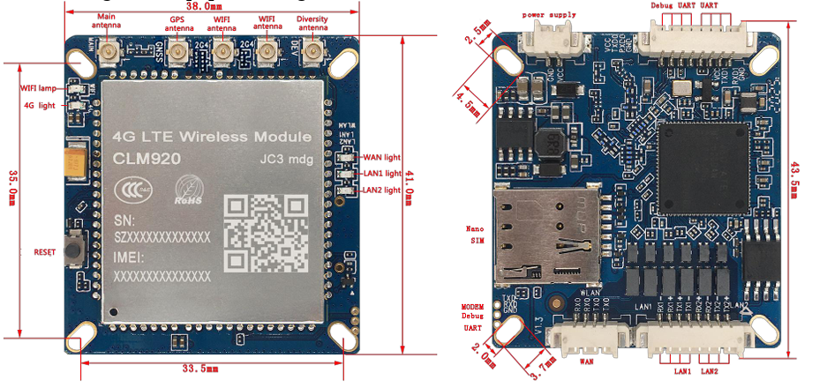

1. The DC power supply voltage range is 6V to 25V, and it is recommended to use a matching power adapter
2. Support LTE network indicator light, flashing when there is no card or unregistered, normally on when registered.
3. Support WAN and LAN network port indicator light and WiFi indicator light.
4. WAN port can be configured as WAN or LAN function on the page
5. Support Factory reset button
6. Please clear the browser's browsing history before using the WEBUI management function

The product pictures, videos and screen contents on the above pages are only for illustration. The physical product effect (including but not limited to appearance, color and size) and screen display content (including but not limited to background, UI, pictures and videos) may be slightly different. Please refer to the physical product. The data in the above pages are theoretical values, which are from the internal laboratory. The actual use may be slightly different due to individual differences, software versions, use conditions and environmental factors. Please refer to the actual use.

Due to the real-time change of product batch and production supply factors, in order to provide accurate product information, specification parameters and product characteristics as far as possible, we may adjust and revise the text expression, picture effect and other contents in the above pages in real time to match the actual product performance, specification, index, parts and other information. If it is necessary to make the above modifications and adjustments, no special notice will be given.

The manufacturer shall make every effort to ensure the accuracy of the information provided, but shall not be liable for any errors or omissions that may exist.