**4G&5G industrial router**

**User's manual**

Catalog

5G industrial router 1

Chapter 1 Setup Preparation 5

1.1 Connection equipment 5

1.2 Log in to the router 7

1.3 Current Status 8

**1.4 System information** 9

Chapter 2 Working Mode 9

**2.1 4G/5G wireless routing mode.** 10

**2.1.2 Disconnection detection function** 12

**2.1.4 AT instruction** 13

2.2 Wired Access Standard Routing Mode 14

2.3 Wireless AP + Client Bridge Mode 15

2.4 Wireless AP + Client Mode 17

Chapter 3 VPN 18

3.1 PPTP 18

3.2 L2TP 19

Chapter 4 LAN Settings 20

4.1 Basic settings 20

**4.2 IP & MAC Binding** 21

**4.3 Allocation Status** 21

Chapter 5 Wireless Function 22

5.12.4G Wireless Settings 22

**5.3 Advanced Settings** 23

**5.4 Wireless User List** 23

**5.5 Wireless MAC Filtering** 24

**5.8 Advanced Settings** 25

**5.9 Wireless User List** 26

**5.10 Wireless MAC Filtering** 26

Chapter 6 Network security 27

**6.1 Firewall Settings** 27

**6.2 Site Control** 27

**6.3 Access Control** 28

**6.4 Port Blocking** 28

Chapter 7 System Services 29

7.1 Virtual Services 29

7.4 Serial port service 31

**7.5 Remote maintenance platform** 32

Chapter 8 Routing Settings 32

Chapter 9 Equipment Management 33

9.1 Equipment function 33

9.2 Software upgrade 35

9.3 Restore the factory value 36

9.4 Password Management 36

Additional content: 37

Instructions for 5G Industrial Router Serial Port 37

5G industrial router as a client to achieve serial data transmission 39

5G industrial router as server to realize remote data transmission 42

Use of 5G Industrial Router Virtual Server (Port Mapping) 45

# Chapter 1 Setup Preparation

## 1.1 Connection equipment

### 1.1.1 Set the IP address of the computer

Before accessing the Web settings page, it is recommended that you set your computer to Obtain an IP Address Automatically and Obtain a DNS Server Address Automatically so that the router assigns the IP address automatically. If you need to assign a static IP address to the computer, you need to set the computer's IP address and the router's ETH port IP address in the same subnet (the router's LAN port default IP address is: 192.168.10.1, and the subnet mask is 255.255.255.0).

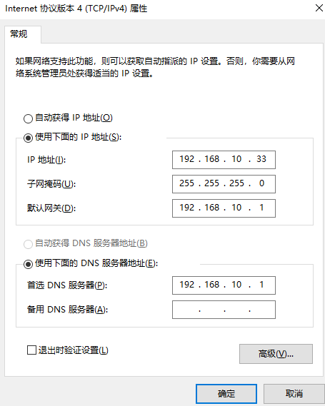

### 1.1.2 Connect via WiFi

Detect the wireless network connection of the wireless router, and then click the'Connect 'button to establish the connection. The wireless password is: 12345678.

### 1.1.3 Verify that the computer is connected to the router

When your computer shows that it has successfully obtained an IP, use the Ping command to confirm that connectivity between the computer and the router is successful.

For example, in a Windows environment, execute the Ping command: Ping 192.168.10.1

If the screen displays the following, the computer has successfully established a connection with the router.

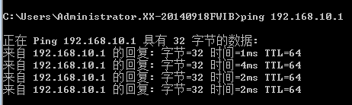

## 1.2 Log in to the router

Next, log in to the router Web settings page.

Enter "http://192.168.10.1" in the Web browser address bar, and enter the login user name and password in the pop-up login authentication box.

When logging in for the first time, please enter the default user name: admin and password: admin.

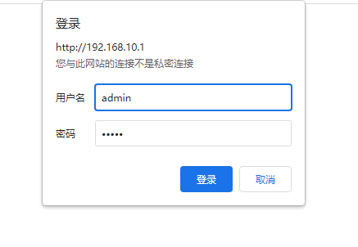

## 1.3 Current Status

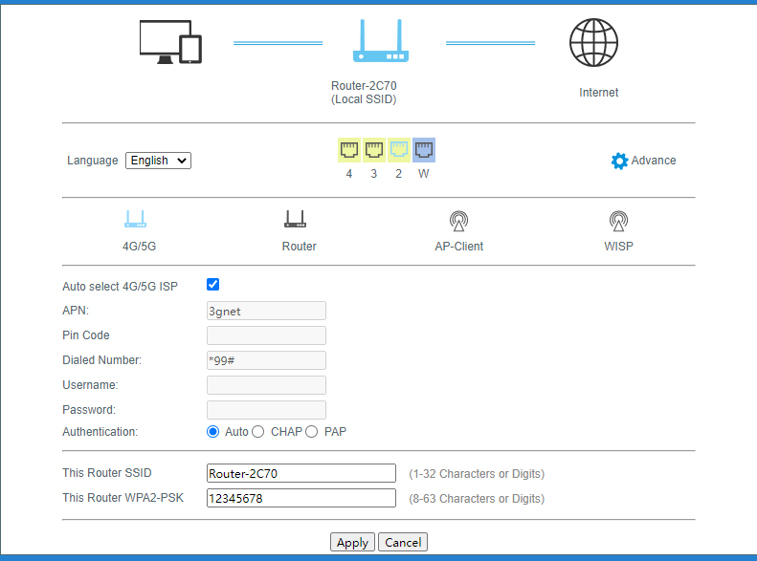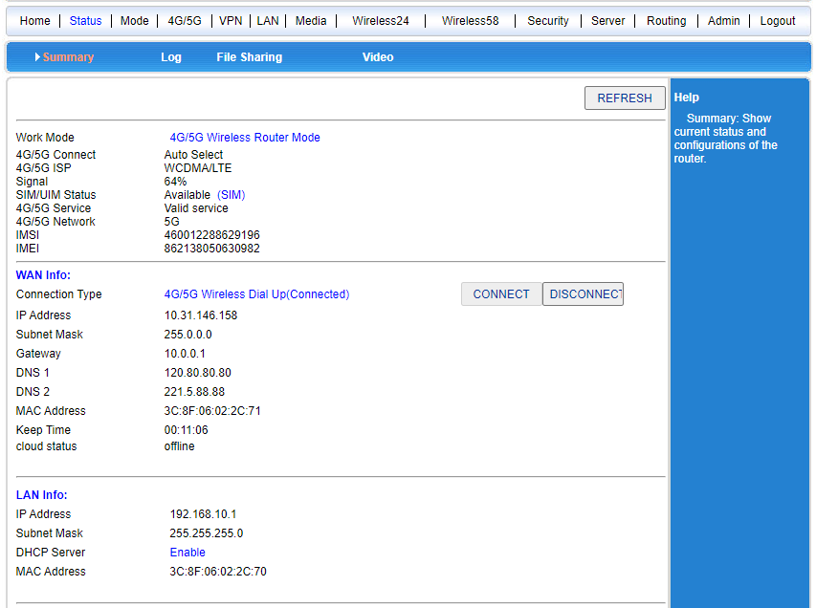

The operational status of the current route.

**1.4 System information**

**You need to check System Log (Device Management-System Log) to record the system log.**

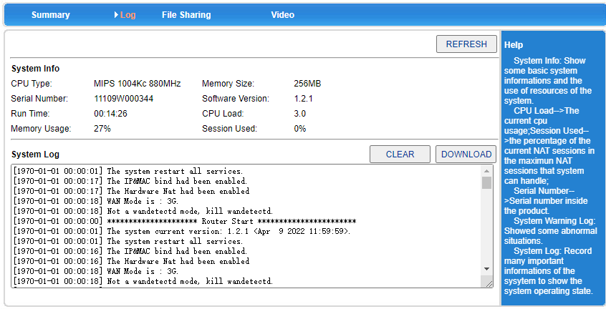

# Chapter 2 Working Mode

The 5G industrial router provides 4 operating modes: 4G/5G wireless routing mode (default), standard wireless routing mode, wireless AP + wireless client bridge mode, and wireless AP + wireless client mode:

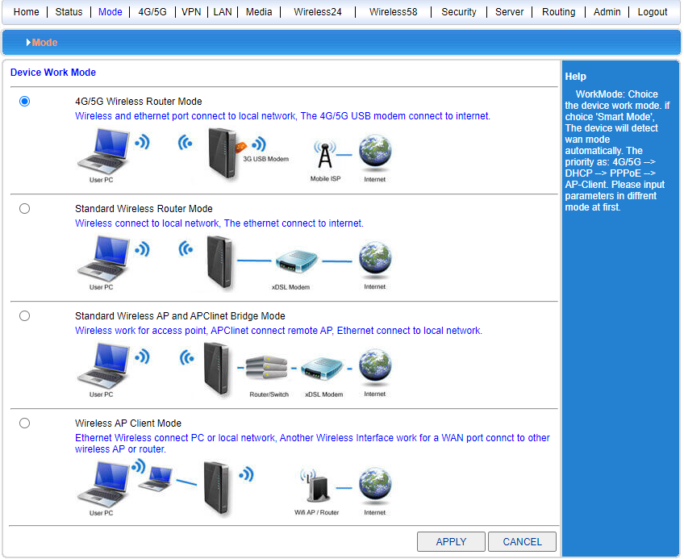

2.1 4G/5G wireless routing mode.

The default of 5G industrial router is 4G/5G wireless routing mode. When the 4G/5G tariff card is inserted, the router will automatically identify the 4G/5G network. You can also customize your network operator.

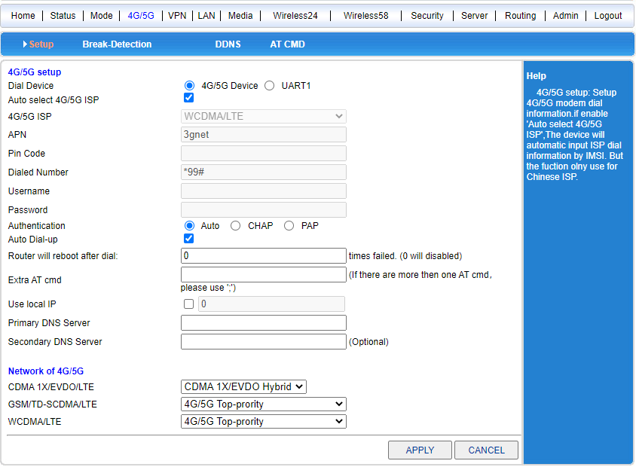

|  |  |  |  |  |  |
| --- | --- | --- | --- | --- | --- |
| Operator | 4G/5G network | APN | Dialing number | User name | Password |
| China Mobile | TD-SCDMA  TDD-LTE | cmnet | * 99 # or * 98 * 1 # | card | card |
| China Telecom | CDMA2000  FDD-LTE | Empty | #777 | Card | card |
| China Unicom | WCDMA  FDD-LTE | 4G/5Gnet | *99# | Empty | Empty |

### 2.1.1 Automatic restart due to dialing failure

The router has the function of automatic restart if the dialing is unsuccessful. The system defaults to restart if the dialing is unsuccessful for 5 times. The 5 times here can be modified manually.

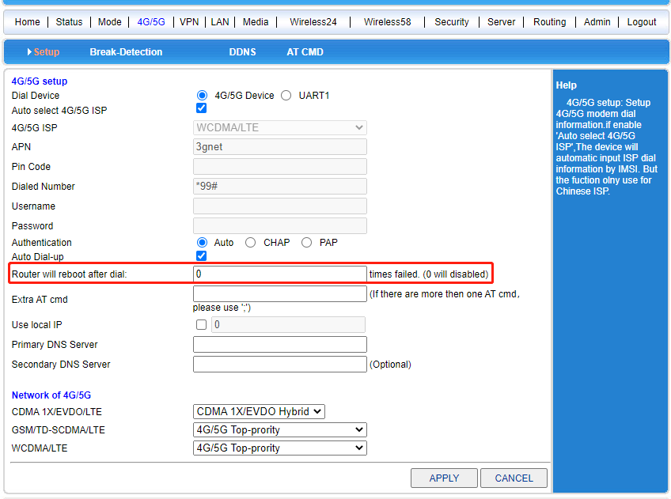

**2.1.2 Disconnection detection function**

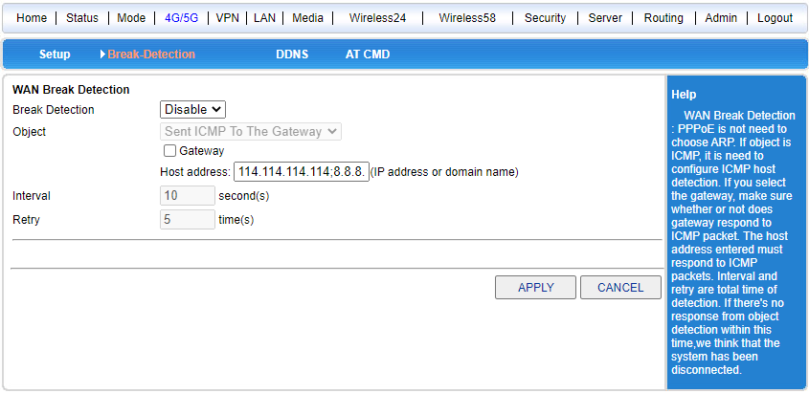

The working principle of disconnection detection is to send a ping packet to the specified IP address or domain name. When the network is normal, the sent ping packet can receive the feedback of the host IP or domain name. If no feedback is received for five consecutive times, the system will judge that the line is disconnected. The number will be redialed. (The interval and the number of retries on the picture can be modified)

### 2.1.3 Dynamic domain name

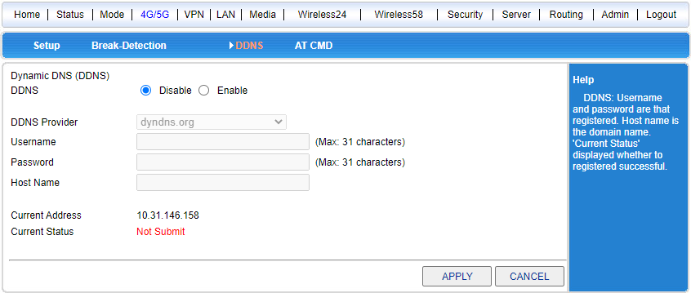

The dynamic domain name (DDNS function) can only be used when the machine obtains the public network IP. At present, the IP address allocated by the operator is basically the intranet IP. The intranet IP has been mapped once on the operator's side, and cannot be mapped for the second time.

**2.1.4 AT instruction**

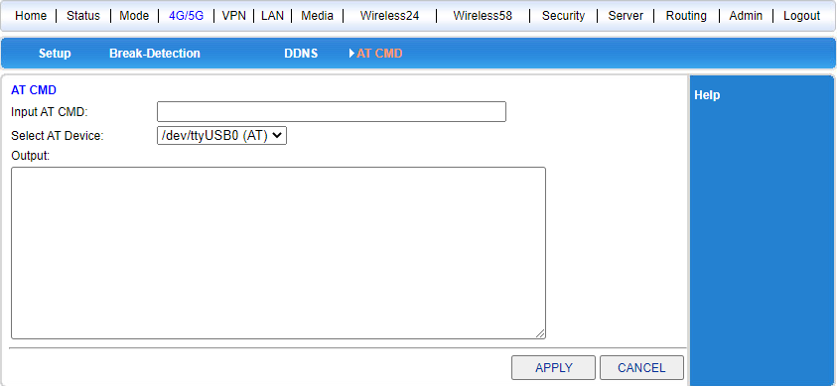

Query the AT command of the communication module, such as CSQ, IMEI, etc.

## 2.2 Wired Access Standard Routing Mode

### 2.2.1 Static Internet access

Enter the working mode of the router management interface, select the standard routing mode, select the static address for WAN setting, input the IP address, network mask, gateway, DNS and other relevant parameters provided by the ISP, and click OK.

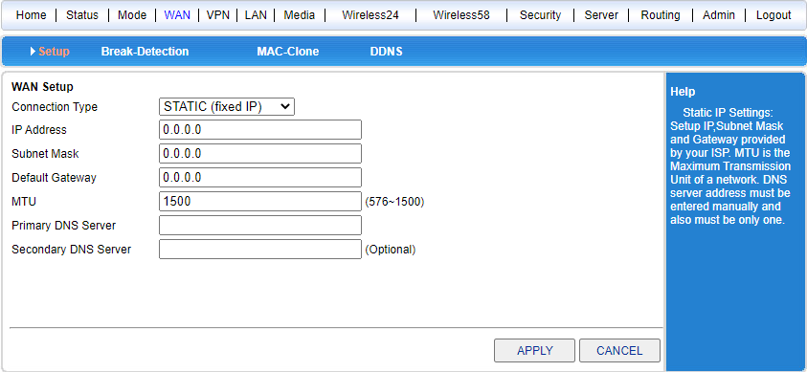

### 2.2.2 Dynamic Internet access mode

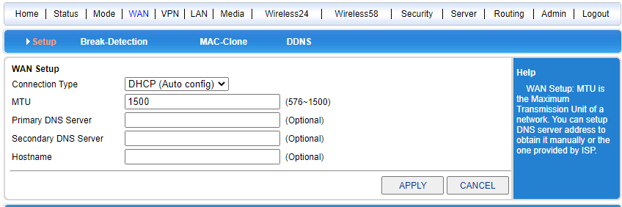

**DHCP dynamic Internet access can be selected.**

### 2.2.3 PPPoE Internet access

Enter the router management interface working mode, standard routing mode, select PPPoE for WAN settings, enter the user name, password and other relevant parameters provided by the ISP, and click OK.

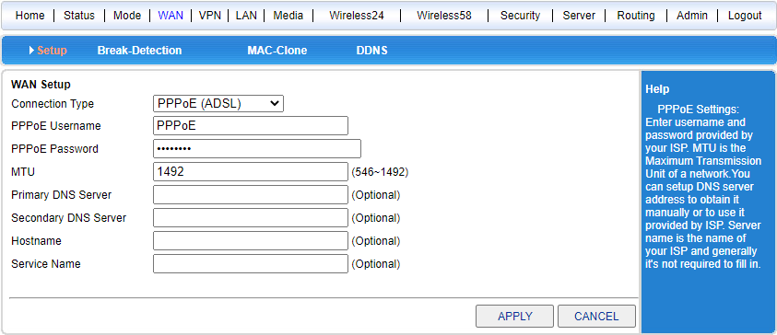

## 2.3 Wireless AP + Client Bridge Mode

After selecting this mode, we can use the 5G industrial router as a bridging AP to bridge the previous wireless router.

1. First, set the local IP of the computer to 192.168.10.100, connect the LAN2 interface through the network cable, enter the router management interface, and select the wireless AP + client bridge mode.

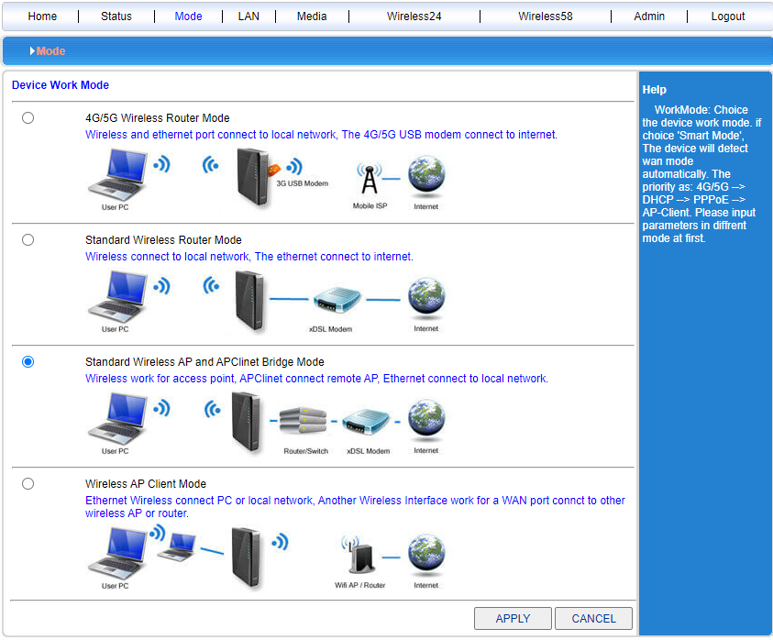

1. Click LAN Settings to search for a wireless network.

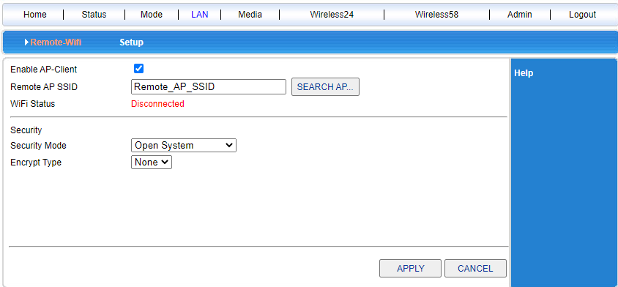

1. You can see the valid wireless AP names in the current range and select the corresponding wireless AP.

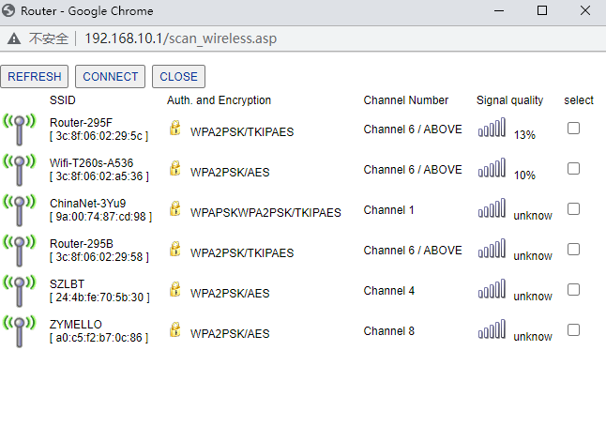

1. Enter the selected wireless AP password to bridge the previous wireless AP.

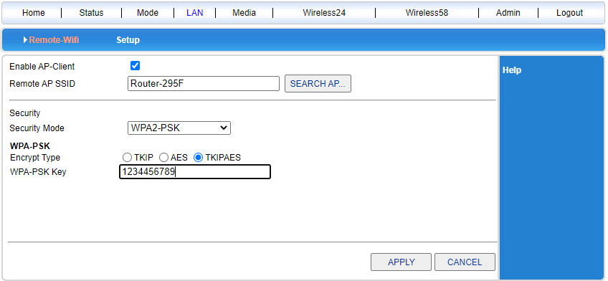

## 2.4 Wireless AP + Client Mode

* Router management interface-working mode-wireless AP + client mode, click OK.
* Wireless Connection-Select ApClinet-Dynamic Address (automatically obtained from the DHCP server) from the drop-down menu of Internet access mode, and click to search for wireless networks. At this time, the selection dialog box of all searched wireless networks will automatically pop up. Select the WIFI network to be connected, and click Connect. If the selected WIFI has a password, please enter the corresponding password in the wireless security below. At this time, pay attention to whether the password is character or hexadecimal. Click OK.

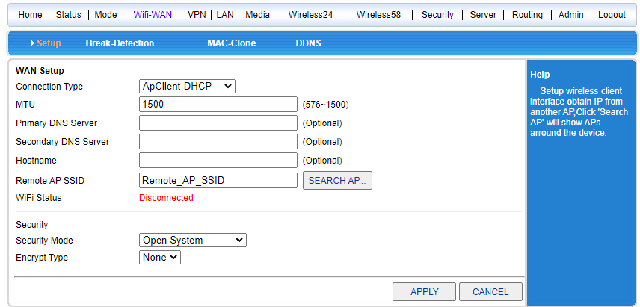

# Chapter 3 VPN

## 3.1 PPTP

The router VPN feature only supports the client side, not the server side. When using the VPN function, be sure to turn off the disconnection detection function, because in the VPN mode, you cannot access the external network. If the disconnection detection function is not turned off, the system will be redialed and restarted.

Select PPTP mode to enable PPTP and PPTP auto connect. Then fill in the PPTP server information, user name and password correctly. Select the corresponding encryption method. Click OK to connect to the PPTP server.

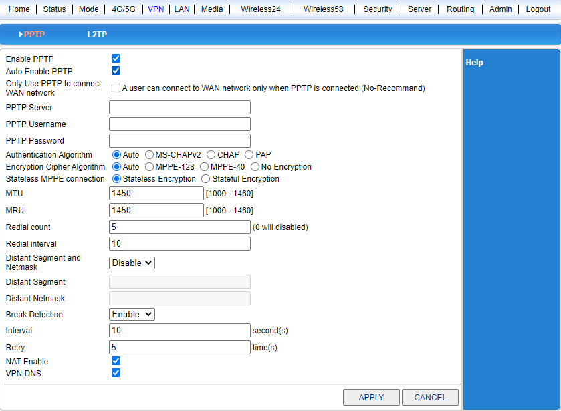

## 3.2 L2TP

Select L2TP mode to enable L2TP and L2TP Auto Connect. Then fill in the L2TP server information, user name and password correctly. Click OK to connect to the L2TP server.

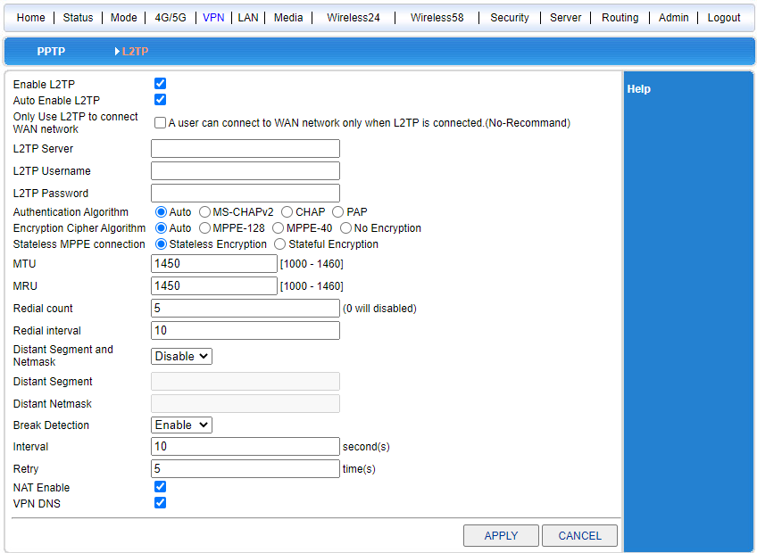

# Chapter 4 LAN Settings

## 4.1 Basic settings

The gateway address can be modified in the LAN settings. Suppose we change the gateway to 192.168.1.1, then we need to change the following DHCP server settings to 192.168.1.2-192.168. 1.254

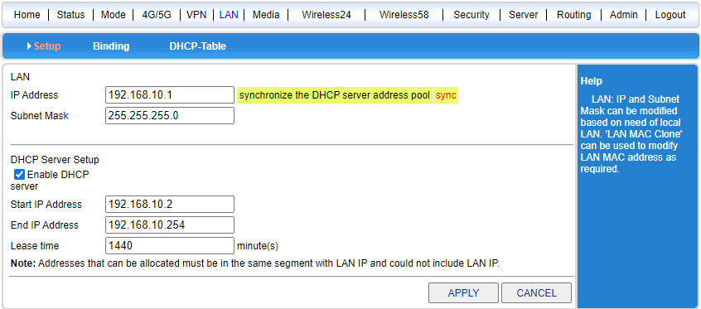

**4.2 IP & MAC Binding**

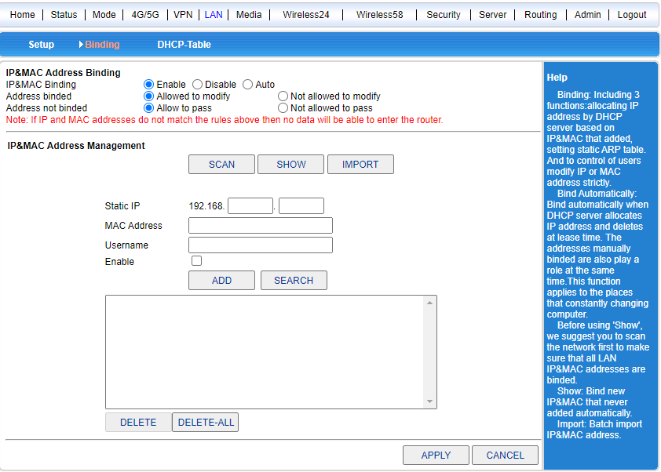

Standard IP & MAC binding function (to be fixed)

**4.3 Allocation Status**

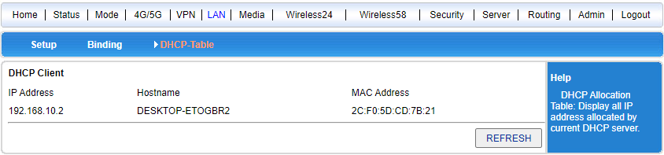

You can see the number of IP connections.

# Chapter 5 Wireless Function

## 5.12.4G Wireless Settings

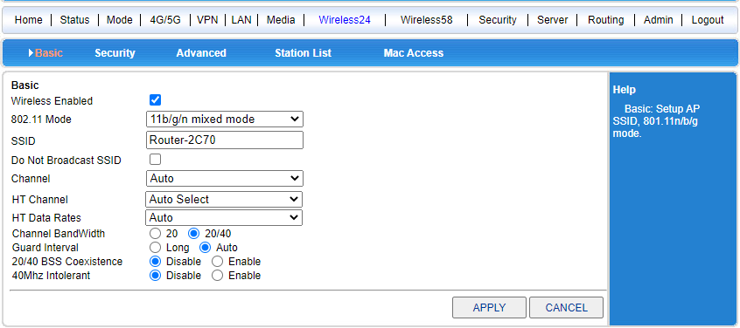

Wireless settings can be enabled and disabled, SSID can be modified, and channel can be modified according to local wireless environment settings;

### 5.2 Wireless Security

Change the password, security mode, and encryption type of wireless.

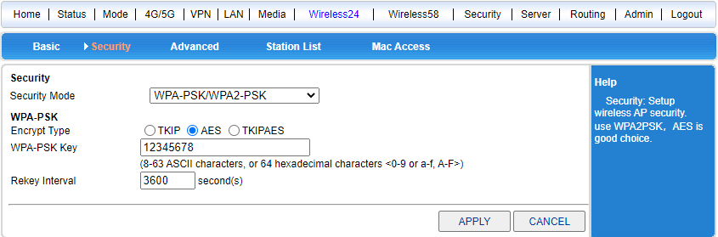

**5.3 Advanced Settings**

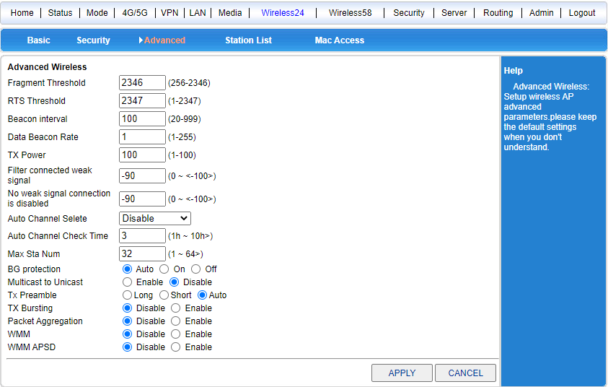

Set up wireless beacons, frequencies, etc.

**5.4 Wireless User List**

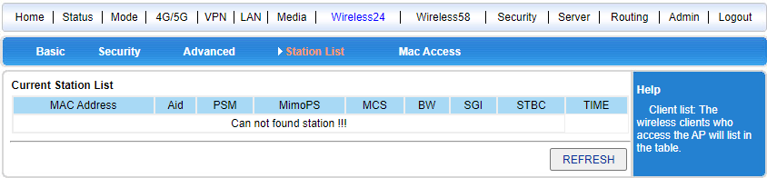

Display the current wireless connection information;

**5.5 Wireless MAC Filtering**

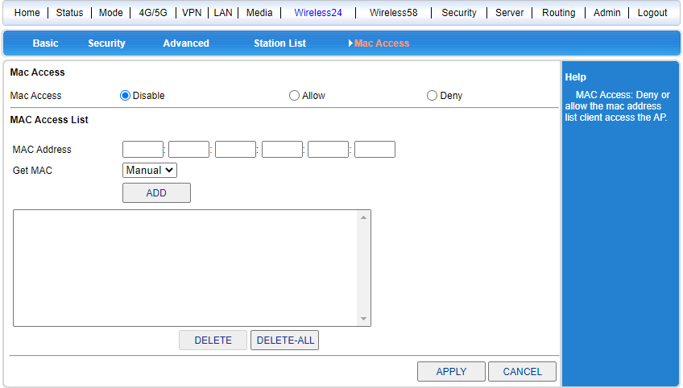

Mac filtering can be added to allow or disallow wireless clients;

**5.6 5.8G Wireless Settings**

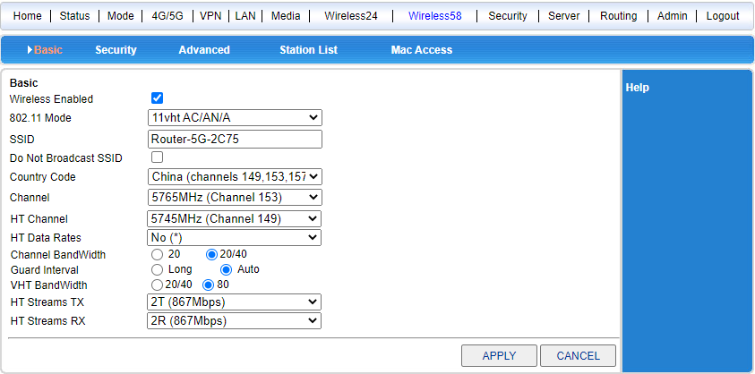

Wireless settings can be enabled and disabled, SSID can be modified, and channel can be modified according to local wireless environment settings;

**5.7 Wireless Security**

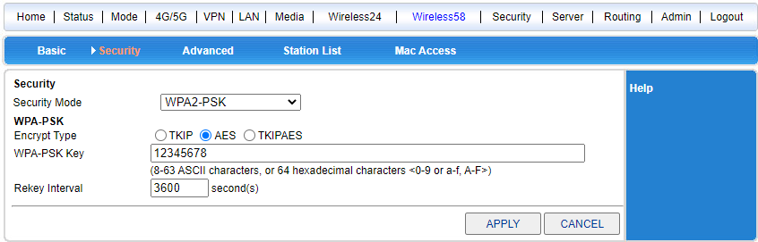

Change the password, security mode, and encryption type of wireless.

**5.8 Advanced Settings**

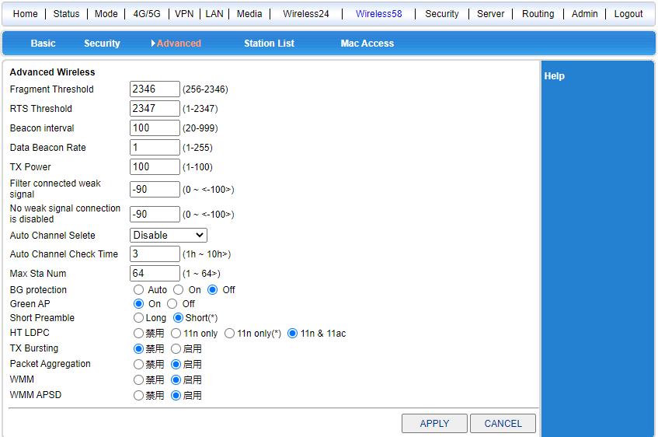

Set up wireless beacons, frequencies, etc.

**5.9 Wireless User List**

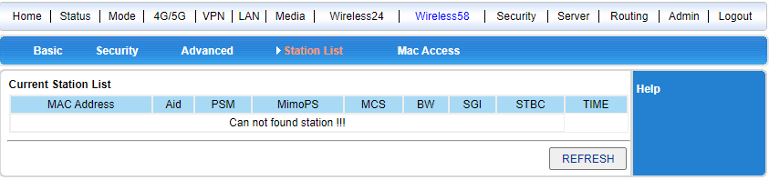

Display the current wireless connection information;

**5.10 Wireless MAC Filtering**

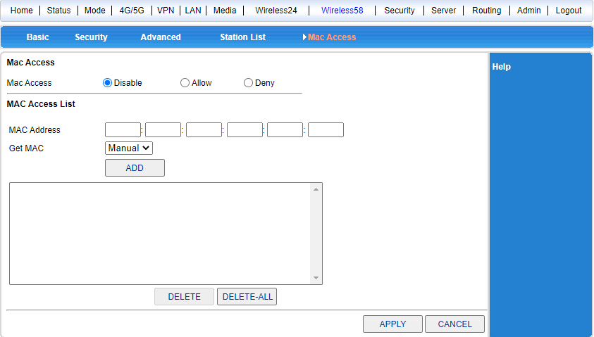

Mac filtering can be added to allow or disallow wireless clients;

1. **Network security**

**6.1 Firewall Settings**

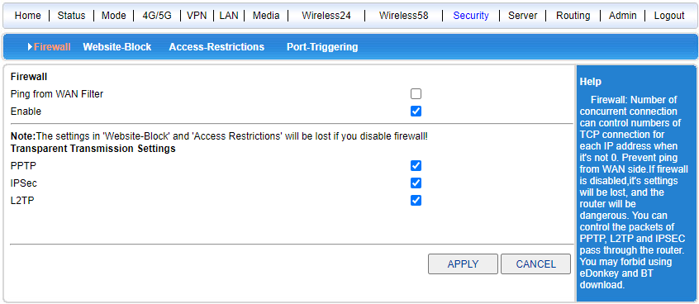

The wanIP prohibits ping, transparent transmission, etc.

**6.2 Site Control**

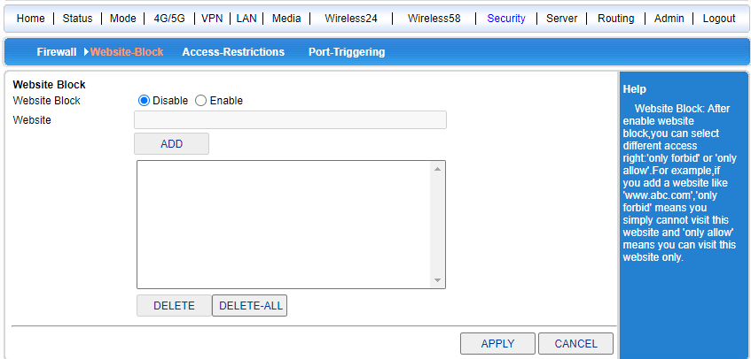

Can be set to prohibit access to the domain name site.

**6.3 Access Control**

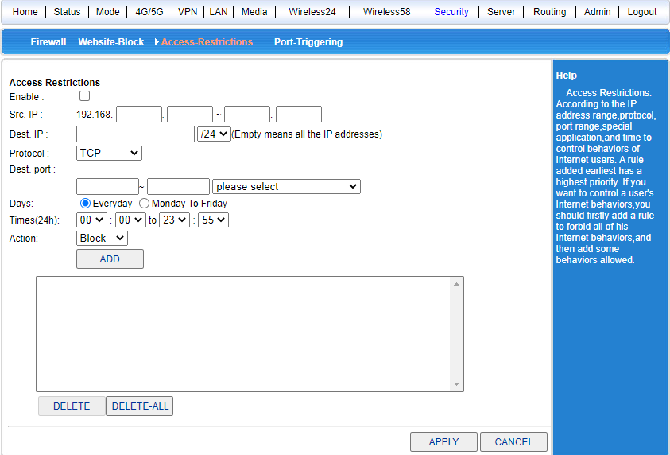

The user's online behavior can be controlled according to IP address range, protocol, port number range, special application and time.

**6.4 Port Blocking**

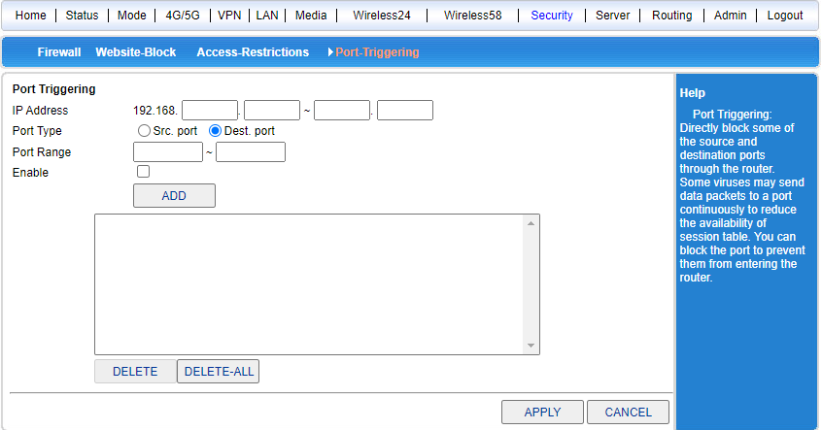

It directly blocks certain source and destination ports from passing through the router, and some viruses send packets continuously to a certain port

# Chapter VII System Services

## 7.1 Virtual Services

The 5G industrial router maps the service port of the intranet server host to the extranet, so that the extranet users can directly access the services provided by the intranet server through the router extranet IP and port. It can be used as a virtual server only by filling in the external port, internal port and internal server IP address correctly.

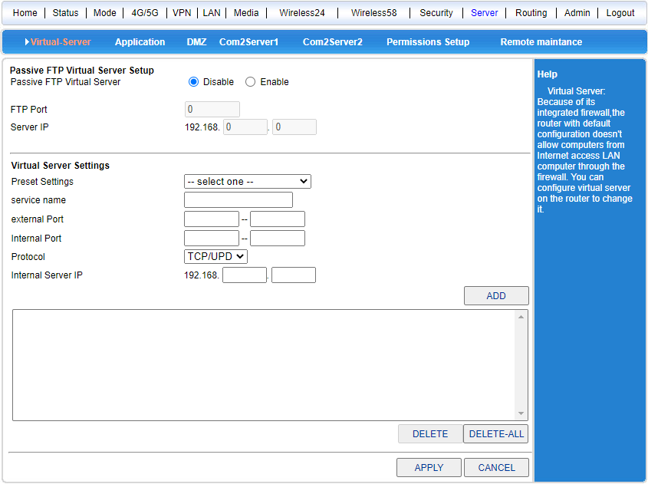

**7.2 Special applications**

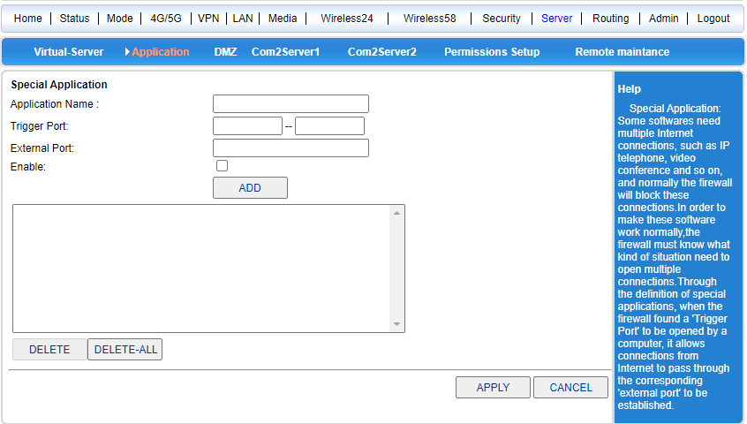

**7.3D MZ Settings**

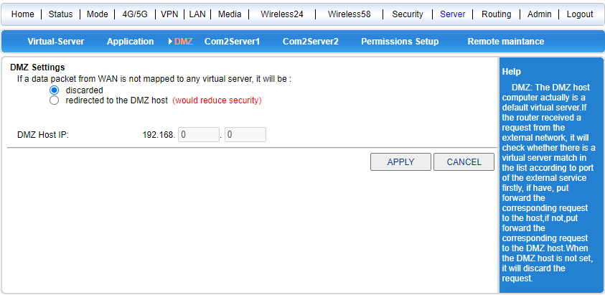

DMZ standard area.

## 7.4 Serial port service

One of the main functions of the 5G industrial router is as a serial server (client), where we can easily connect many serial terminals.

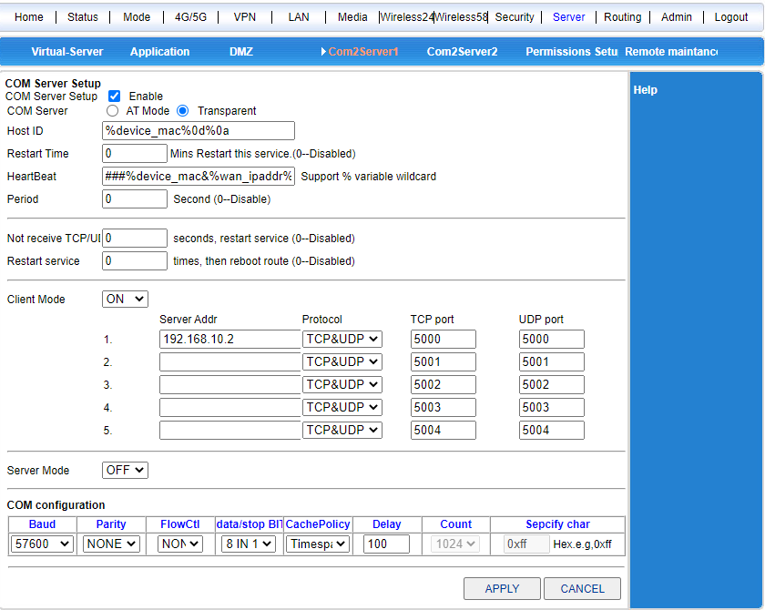

**7.5 Remote maintenance platform**

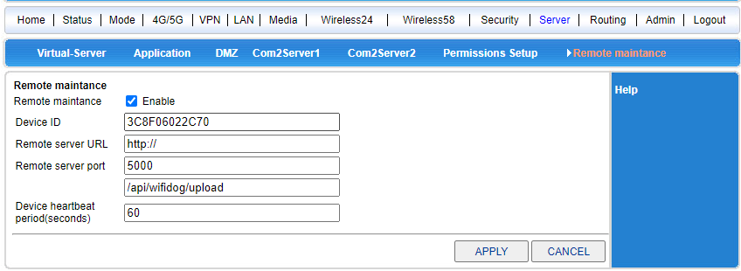

After the equipment is entered into the background, the routing equipment can be remotely controlled by logging in the background of the cloud platform.

**Chapter 8 Routing Settings**

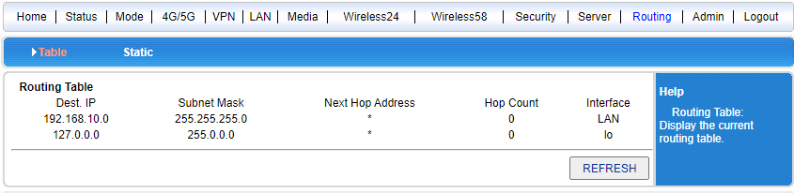

Routing tables and static routes are added.

# Chapter IX Equipment Management

## 9.1 Equipment function

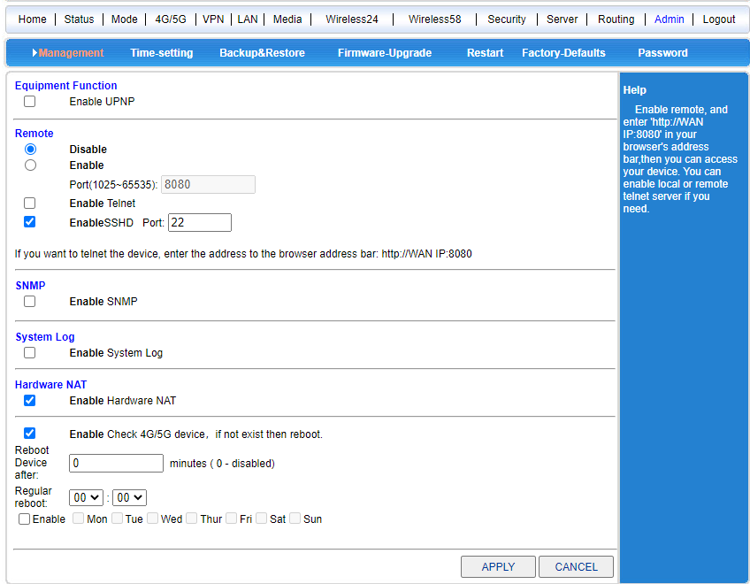

1. UPnP protocol is used by Windows ME, 2000, XP and other systems. If this feature is enabled, it will cause these operating systems to automatically find the router through the protocol.

UPnP (Universal Plug and Play) is mainly used to realize the intelligent interconnection and interoperability of devices, which can automatically discover and control various network devices from various manufacturers without user participation and use of the main server.

With UPnP enabled, the router can implement NAT traversal: when computers in the LAN pass through.

When the wireless router communicates with the Internet, the wireless router can automatically add or delete the NAT mapping table as required, thereby solving the problem that some traditional services (such as MSN voice and video) cannot pass through the NAT.

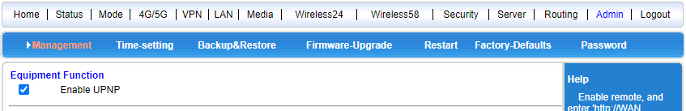

Check the radio box and press the button to complete the setting.

2, system log, sometimes we encounter problems in use, find the manufacturer staff, the staff will ask the customer to give a system log. However, the system log is closed by default, so you need to open the log before you can record the system operation.



3. System startup: The system restarts every 240 minutes by default. This time can be set manually. 0 to turn off this feature.



4. SNMP network management function

## 9.2 Software upgrade

Software upgrade allows you to load the latest version of software onto the router for more functionality and more stable performance.

Software upgrade steps are as follows:

(1) Save the upgrade file of the router to the local computer.

(2) Click the < Browse > button to select the software to be upgraded.

(3) Click the < Upgrade > button to start the upgrade.

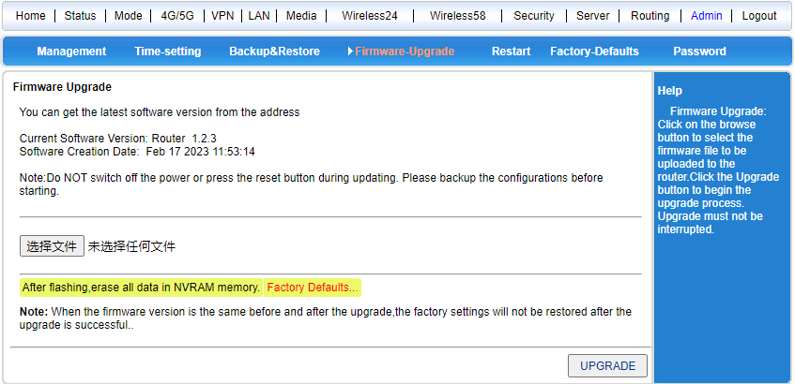

## 9.3 Restore the factory value

Restoring to the factory settings will clear all the settings information of the wireless router and restore to the original state. This function is generally used when the device changes from one network environment to another different network environment, restores the device to the factory settings, and then resets it to be more suitable for the current networking.

Click the < Restore factory settings > button. After confirmation, restore the factory settings.

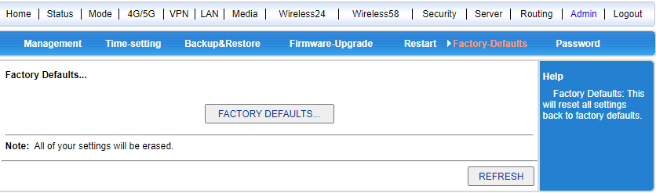

## 9.4 Password Management

The default user name/password of the wireless router is admin. The user name cannot be modified, but the password can be modified. For the sake of security, it is recommended to modify this password and keep the password information.

The setting steps are as follows:

(1) Enter the original password in the < Original password > text box; Enter the new password in the New Password text box and reenter the new password in the Confirm Password text box to confirm it.

(2) Click the < OK > button to complete the password change.

Additional content:

## Instructions for 5G Industrial Router Serial Port

1. The serial port service is divided into serial port command mode and serial port transparent transmission mode.
   1. Serial port command mode: You can send some commands to the wireless router through the serial port to obtain relevant information such as the current time, the current network type, the total network traffic at that time, and the current 4G/5G signal strength. For detailed commands, see the following serial port command list.
   2. Serial port transparent mode: The server address and port to be connected can be set, so that the 4G/5G router can be connected to the designated TCP or UDP server to establish a transparent data transmission channel and realize transparent data transmission.
   3. If the serial port service function is set to be turned on at power-off, it will automatically connect to the specified server at power-on and be in the serial port transparent mode
   4. If the serial port service function is set to be off during power-off, the serial port is in the command mode during power-on, and the serial port command can be received directly
   5. Send "+ + +" when returning from serial port transparent mode to serial port command mode, and send "ATO" when returning from serial port command mode to transparent mode.
2. The serial port transparent mode is also divided into a client mode and a server mode,
   1. The client mode is a common mode, and the remote server is automatically connected after being powered on to establish a transparent data channel.
   2. The server mode is listening, waiting for the client to connect. At present, only the IP allocated by the network of China Telecom is visible to the public network, which can be used as a server. However, the IP allocated by China Mobile and China Unicom is the internal network IP, which can not be accessed by the external network and generally can not be used as a server.
   3. If you want to use it as a server, you can also use the DDNS dynamic domain name resolution function. That is to say, the random IP allocated to each Internet access is fixed with a fixed domain name, and the client only needs to connect to this fixed domain name without fear that the IP will always change.
   4. At present, there are many commonly used service providers that can provide DDNS services, such as "Peanut Shell", "3322", etc. You only need to go to these service providers, apply for domain name, user name, password and other relevant information, and fill in the DDNS settings of the 4G/5G router. The 4G/5G router can automatically log in to the corresponding service provider when powered on to complete the domain name.
3. If the serial port function is closed, it means that the transparent serial port function is closed, and the serial port command can be used at this time.

## 5G industrial router as a client to achieve serial data transmission

* + 1. Use the serial port of a computer (terminal A) and the serial port connector of 5G industrial router, which are GND/TX1/RX1 from the rightmost side, to connect to the serial port of the computer, which should be GND/RX/TX, that is, pin 5, pin 2 and pin 3.
    2. Use another computer (server B) to link the 5G industrial router through the network cable or WIFI, open the wireless router setting page of 192.168.10.1, open "System Service", and select "Serial Port Service" to set it.

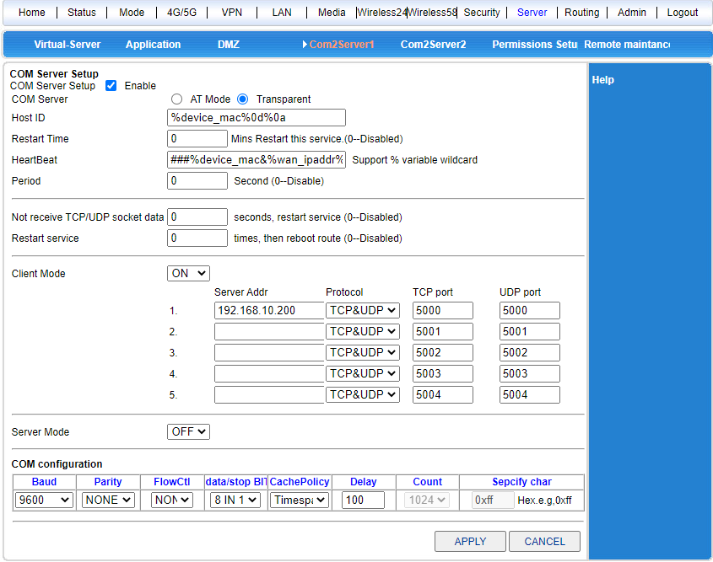

* + 1. Install the server serial port software in computer B, and set the server type: TCP server, server IP address: 192.168.10.2, port: 5000. The router will automatically discover the end device and indicate that the connection is successful. Some software will automatically obtain the local IP address, can not be modified, then enter the WEB interface, modify the parameters of the serial port service of the router, so that the server address and port are one-to-one correspondence.

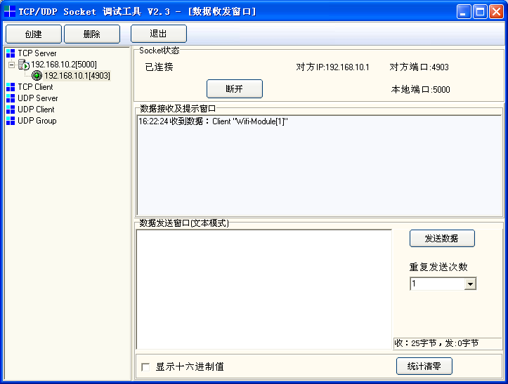

* + 1. Computer A opens HyperTerminal and selects COM1 to connect. Note that the baud rate and other parameters should be the same as the WEB interface settings of the router.

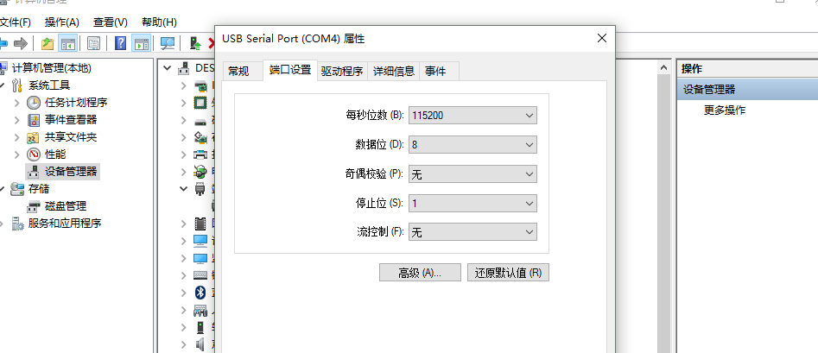

* + 1. Now, between computer A and computer B, data can be transmitted transparently.

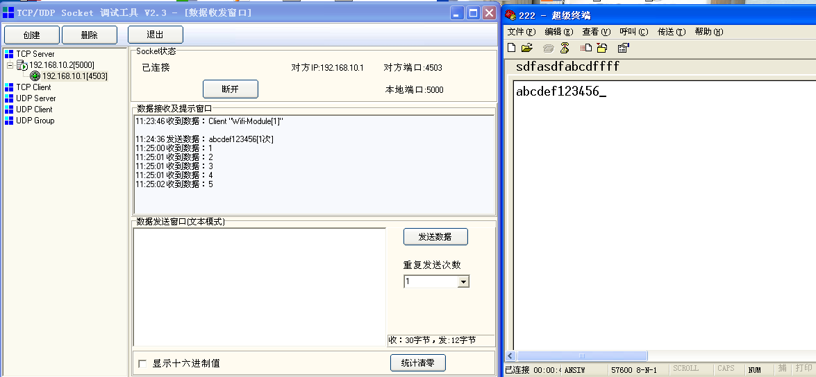

## 5G industrial router as server to realize remote data transmission

1. First of all, we need to register a DDNS account. Here, we use peanut shells to do the test. The peanut shell account applied for is the szlbt. Xicp. Net.
2. Enter the user management interface of 5G industrial router 4G/5G Settings-Dynamic Domain Name, and fill in the DDNS account information to ensure that the account can be registered successfully.

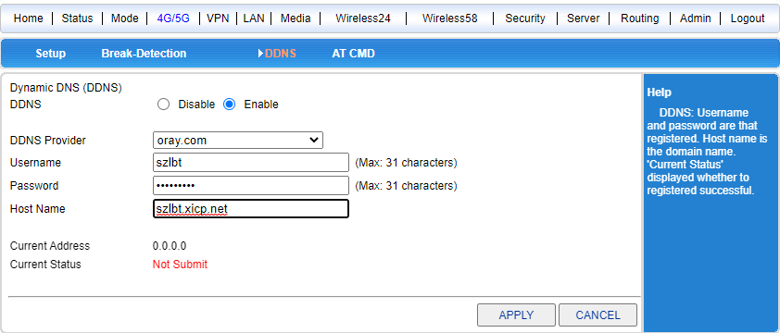

1. Enter the system service-serial port service to enable the server function of the 5G industrial router.

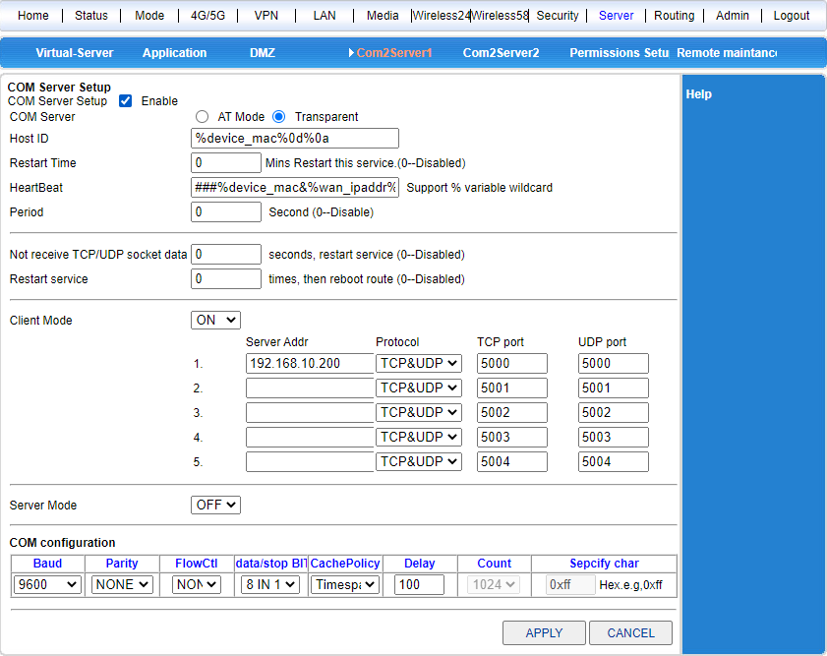

1. The 5G industrial router is connected to the Internet through the telecom 4G/5G network. In particular, the current domestic 4G/5G network does not provide public network IP, so DDNS cannot be used, and DDNS can only be used through the fixed network with public network IP.
2. Find a computer at random, ping szlbt. Xicp. Net, and get the IP address of the 5G industrial router. The IP address currently obtained is 113.113.105.150.

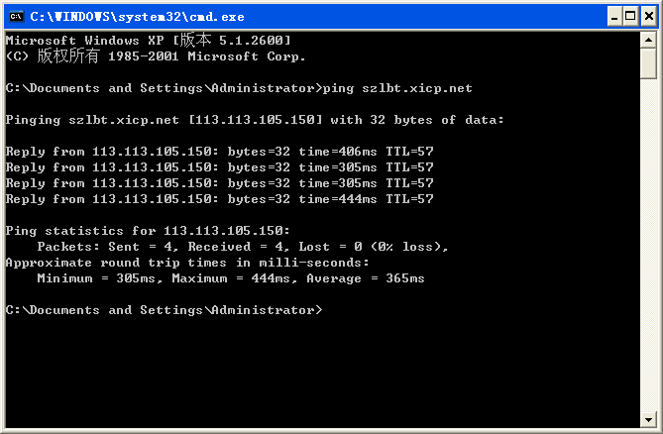

1. Install TCP client software on the computer and make corresponding settings.

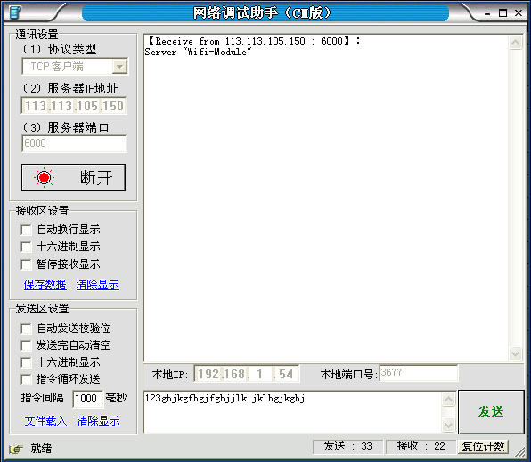

1. The 5G industrial router connects a computer through a serial port and opens the super terminal to get the data sent by the client.

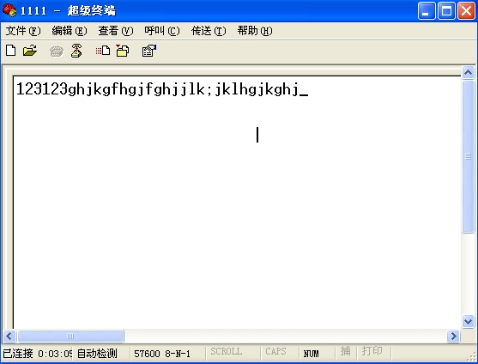

## Use of 5G Industrial Router Virtual Server (Port Mapping)

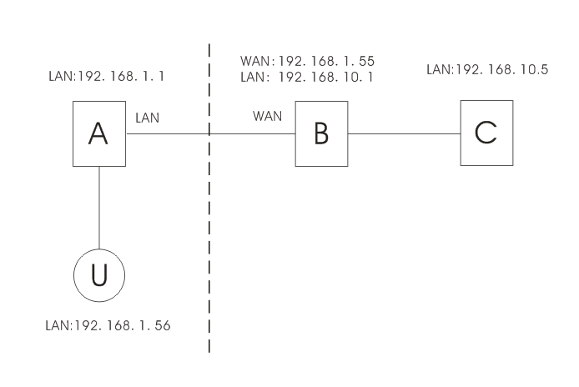

As shown in the figure, there are three routers A, B (5G industrial router) and C, and U is the user side. A and U are in the same LAN. A's IP address is 192.168.1.1, and U's IP address is 192.168.1.56. B and C are in another LAN, and their IP addresses are 192.168.10.1 and 192.168.10.5 respectively. The WAN port of router B is connected to the LAN port of router A, and the obtained WAN address is 192.168. 1.55.

The definition of virtual server is that user U accesses router B through A across the network, and router B automatically transfers the service request

To the server (router) C.

Here, the way B is connected and set up is very important. The connection mode is required as follows:

1. B is connected to the external network through the WAN port.
2. B is connected to C with a LAN port.

Setting method: Enter the setting interface of router B-System Service-Virtual Service, and set the parameters as follows:

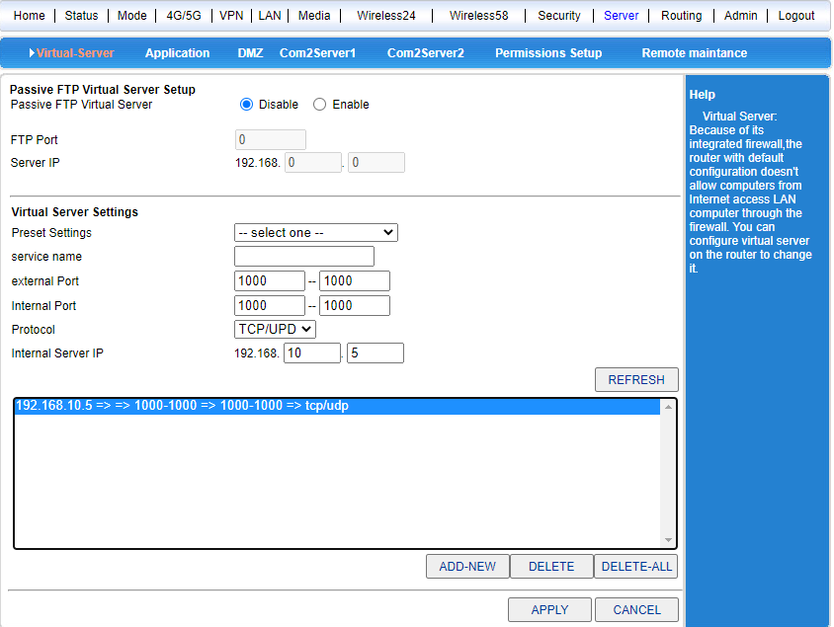

The external port can be filled in at will, and the internal port should be consistent with the corresponding service port of server (router) C (port 80 is the WEB configuration interface port of router C).

After filling in according to the above content, save it.

Now, we connect to router A through client U, and type in the address bar:<http://192.168.1.55:1000> Press Enter, and the browser will directly enter the setting interface of router C.